2.5 I can change the file formats of documents appropriately for content

When creating documents I make sure to save the document using the relevant file format using the drop down option available when saving the file;

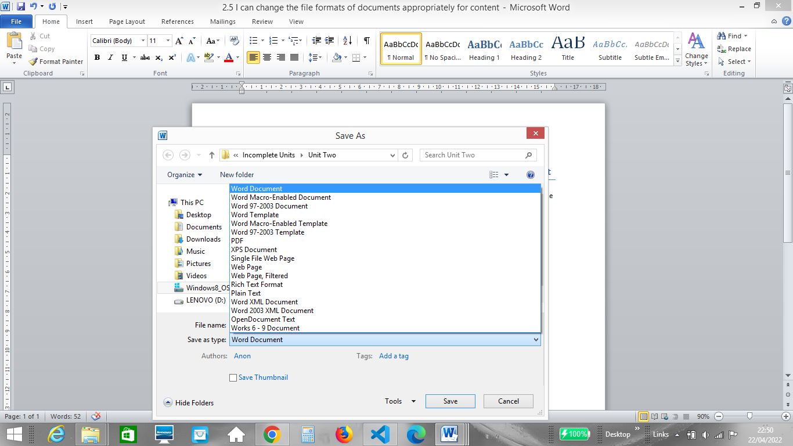

Below is an example of the files that make up my website, this includes jpeg files, a css file and a html file;

